**What do we need to know for the flight?**

* How do astronauts go to the bathroom? Do we need toilet paper? Do we need feminine napkins?
* Do we need to take oxygen and nitrogen to mix our “air”? Any other gases needed? “Air” is 78% nitrogen, 21% oxygen, and less than 1% of argon, carbon dioxide, and other gases — as well as varying amounts of water vapor.
* Can we take a large “greenhouse” as a source of fresh food and oxygen? How much water does a vegetable garden use? Can a “greenhouse” be self-sufficient (not need additional water, nitrogen, etc.)?
* Should we “mix” our water from oxygen and hydrogen? How to “make” water? Mix the gases and heat the mixture.
* We need to filter carbon dioxide from the ship atmosphere.
* How much “air” does an adult human consume per day? 7-8 liters per minute, 11,000 liters per day
* How much water does an adult human consume per day? 3 liters.
* How much does an adult human pee per day? 2 liters
* What can we do with poop? Keep for future fertilizer? Make methane?
* What fuel will the ship engines use? Nuclear? Solar?
* Distance and time to Mars:
  + Farthest: 250,000,000 miles (approx.. 289 days, approx.. 9. 5 months)
  + Shortest: 34,000,000 miles (approx.. 39 days @ 36,000 miles/hour)
* Current Nasa timetable for manned-mission to Mars: 2035 (as of 9/13/2015)
* Specifically, these two proposed missions (to Mars and the outer planets) would use a 2 MegaWatt Nuclear Electric Propulsion spacecraft equipped with an EM Drive with a thrust/powerInput of 0.4 Newton/kW.
* With this design, a mission to Mars would result in a 70-day transit from Earth to the red planet, a 90-day stay at Mars, and then another 70-day return transit to Earth.
* The Orion Multi-Purpose Crew Vehicle is a spacecraft intended to carry a crew of up to four astronauts to destinations at or beyond low Earth orbit. [Wikipedia](http://en.wikipedia.org/wiki/Orion_(spacecraft))
* Nasa Orion spacecraft:

[**Max speed**](https://www.google.com/search?safe=active&espv=2&biw=1093&bih=545&q=orion+spacecraft+max+speed&stick=H4sIAAAAAAAAAGOovnz8BQMDgz4HnxCnfq6-gVFSerqplkJ2spV-cUFicmpaTmZ6RgmEnVyUmFZiVVyQmppyP9x05cllXk6svodnhhRb3ZN_NFkaACsxYxNMAAAA&sa=X&ved=0CKABEOgTKAAwG2oVChMIl9qe6Pz0xwIVhaOICh0BKgWp)**:**20,000 mph

[**Manufacturers**](https://www.google.com/search?safe=active&espv=2&biw=1093&bih=545&q=orion+spacecraft+manufacturers&stick=H4sIAAAAAAAAAGOovnz8BQMDgxkHnxCnfq6-gVFSerqplnp2spV-cUFicmpaTmZ6RgmEnVyUmFZilZuYV5qWmFxSWpRaNGXnTu_lGrcaVj8QVFs4Mfjp8cM-2gBGa26cUwAAAA&sa=X&ved=0CKMBEOgTKAAwHGoVChMIl9qe6Pz0xwIVhaOICh0BKgWp)**:**[Astrium](https://www.google.com/search?safe=active&espv=2&biw=1093&bih=545&q=eads+astrium&stick=H4sIAAAAAAAAAGOovnz8BQMDgxMHnxCnfq6-gVFSerqpEheYaW6Ya1aspZ6dbKVfXJCYnJqWk5meUQJhJxclppVY5SbmlaYlJpeUFqUWLTcq_HnDKMn8WvgWJtPz5XzbPVZpAwAzsLxvXwAAAA&sa=X&ved=0CKQBEJsTKAEwHGoVChMIl9qe6Pz0xwIVhaOICh0BKgWp), [Lockheed Martin](https://www.google.com/search?safe=active&espv=2&biw=1093&bih=545&q=lockheed+martin&stick=H4sIAAAAAAAAAGOovnz8BQMDgwMHnxCnfq6-gVFSerqpEgeImZFdmKelnp1spV9ckJicmpaTmZ5RAmEnFyWmlVjlJuaVpiUml5QWpRZ5cnFH7pxpsaxu9le7e6zqsw65z7AHAOcO_E9dAAAA&sa=X&ved=0CKUBEJsTKAIwHGoVChMIl9qe6Pz0xwIVhaOICh0BKgWp)

Closest approach: 34,000,000 (approx. 70 days)

* Light-speed: 286,000 miles/sec
* Orion Spacecraft main components:
  + Launch Abort System
  + Crew Module (aka the washing machine)
  + Service Module (carries rocket engines for propulsion, large solar panels for generating electrical power and oxygen for the astronauts to breathe)
  + Spacecraft Adapter (a set of panels for protecting the Service Module during the ascent through the Earth’s atmosphere)
  + An Instrument Unit contains guidance and control electronics for the booster rocket
* Will the first manned mission to Mars land???
* First-stage, second-stage, third-stage separation: at which altitudes and speeds and times into flight?

Stage Separation time into flight Altitude Speed

First (SRBs) 120 seconds 75 miles ???

Second (main engine) ??? ??? ???

Third (ICPS) ??? 3600 miles ???

* Homework for Sun. 9/20:
  + Lauren: 1st stage
  + Ryan: 2nd stage
  + Dylan: 3rd stage
  + Javier: all stages
* SLS: Space Launch System

**What do we need to know to colonize?**

**What we need to take with us for the flight**

* A feet! (at least two ships)
* Water (how much???)
* Oxygen (mix it in flight???)
* Food (in what form??? Freeze-dried?)
* Solar panels
* Medicines (look at the size of CVS’s pharmacy section!)
* Toilet paper? Feminine napkins? How do astronauts go to the bathroom in space?

**What we need to take with us to colonize**

* Batteries
* Vehicles
* Communication equipment

**Who we need to take with us**

* **Doctor(Surgeons, Nurses, Pediatricians, Cardiologists, Internal Medicine, Psychiatrists, Ophthalmologists (eye-ear-nose), Neurologists, Pulmonologists, Anesthesiologists)**
* **Engineers (Aerospace, Civil, Environmental, Mining, Electrical)**
* **Scientists (Geologists, Physicists, Botanists, Mars Climatologists, water quality scientists)**
* **Skills (Mechanics)**
* **Lauren (Life Science Officer)**
* **Ryan (Doctor)**
* **Dylan(Aerospace Officer)**
* **Javier (Environmental Officer)**

**Research**

* **9/13/15**
* **Lauren:** Can a “greenhouse” be self-sufficient (not need additional water, nitrogen, etc.)? Has it been done with a “closed system”? See Univ. of Arizona BioSphere2.
* **Dylan:** How long will the flight take? How much engine “fuel” will we need? What type of fuel?
* **Ryan:** How can we prevent bone and muscle mass loss? What type of exercise? How long each day?
* **Javier:** How to filter carbon dioxide? What to do with it? What do we need for life support?

MIT Technology Review. Can Sucking CO2 Out of the Atmosphere Really Work? By Eli Kintisch on Oct. 7, 2014. Eli Kintisch is a correspondent for Science magazine.

<http://www.technologyreview.com/featuredstory/531346/can-sucking-co2-out-of-the-atmosphere-really-work/>

Physicist Peter Eisenberger from Columbia University and his 5-year old startup Global Thermostat

<http://globalthermostat.com/>

“Climate Engineering, based in Calgary, captures carbon using a liquid solution of sodium hydroxide, [a well-established industrial technique](http://www.technologyreview.com/article/429736/carbon-capture/).”

“There already exists a well-established, billion-dollar market for carbon dioxide, which is used to rejuvenate oil wells, make carbonated beverages, and stimulate plant growth in commercial greenhouses.”

**“**The idea is to first sell carbon dioxide to niche markets, such as oil-well recovery, to eventually create bigger ones, like using catalysts to make fuels in processes that are driven by solar energy.”

**“**They focused on air capture, which was first developed by Nazi scientists who used liquid sorbents to remove accumulations of CO2 in submarines.**”**

**“**Engineers have previously deployed amines to scrub CO2 from flue gases, whose temperatures are around 70 °C when they exit power plants. Subsequently removing the CO2 from the amines—“regenerating” the amines—generally requires reactions at 120 °C. By contrast, Eisenberger calculated that his system would operate at roughly 85 °C, requiring less total energy. It would use relatively cheap steam for two purposes. The steam would heat the surface, driving the CO2 off the amines to be collected, while also blowing CO2 away from the surface.**”**

“The startup has partnered with a Carson City, Nevada-based company called Algae Systems to make biofuels using carbon dioxide and algae.”

“It’s a warm December afternoon in Silicon Valley as Eisenberger and I make our way across SRI International’s concrete research center. It’s in these low-slung buildings where engineers first demonstrated Arpanet, Apple’s Siri software, and countless other technological advances. About a quarter mile from the entrance, a 40-foot-high tower of fans, steel, and silver tubes comes into view. This is the Global Thermostat demonstration plant. It’s imposing and clean. Eisenberger gazes at the quiet scene around the tower, which includes a tall tree. “It’s doing exactly what the tree is doing,” says Eisenberger. But then he corrects himself. “Well, actually, it’s doing it a lot better.”

“Global Thermostat chose SRI as its site due to the facility’s prior experience with carbon-capture technology.”

“The rectangular tower uses fans to draw air in over alternating 10-foot-wide surfaces known as contactors. Each is comprised of 640 ceramic cubes embedded with the amine sorbent. The tower raises one contactor as another is lowered. That allows the cubes of one to collect CO2 from ambient air while the other is stripped of the gas by the application of the steam, at 85 °C. For now that gas is simply vented, but depending on the customer it could be injected into the ground, shipped by pipe, or transferred to a chemical plant for industrial use.”

“A key challenge facing the company is the ruggedness of the amine sorbent surfaces. They tend to decay rapidly when oxidized, and frequently replacing the sorbents could make the process much less cost-effective than Eisenberger projects.”

“A more practical way to do it, Schrag says, would involve deriving fuels from biomass—which removes CO2 from the atmosphere as it grows. As that feedstock is fermented in a reactor to create ethanol, it produces a stream of pure carbon dioxide that can be captured and stored underground. It’s a proven technique and has been tested at a handful of sites worldwide.”

**“**After Eisenberger earned a PhD physics in 1967 at Harvard, stints at Bell Labs, Princeton, and Stanford followed. At Exxon in the 1980s he led work on solar energy, then served as director of Lamont-Doherty, the geosciences lab at Columbia. There he has taught a long-standing seminar called “The Earth/Human system.”

**Physicsworld.com,** Apr 16, 2015

**How to efficiently capture carbon dioxide out of thin air**

[**http://physicsworld.com/cws/article/news/2015/apr/16/how-to-efficiently-capture-carbon-dioxide-out-of-thin-air**](http://physicsworld.com/cws/article/news/2015/apr/16/how-to-efficiently-capture-carbon-dioxide-out-of-thin-air)

**“**A novel synthetic material that is a thousand times more efficient than trees at capturing carbon dioxide from the atmosphere was presented by [Klaus Lackner](http://engineering.asu.edu/cnce/klaus-lackner/), director of Arizona State University's new Center for Negative Carbon Emissions, at a meeting of the American Physical Society in Maryland last Sunday.**”**

**“**The collectors trap between 10 and 50% of the total carbon dioxide that passes through.**”**

“The question also remains of what to do with the carbon dioxide once it is trapped. Burying it is one option, which is something Lackner says is likely, given the sheer quantity of carbon that must be captured. His centre is also testing ways to recycle the carbon dioxide and sell it to industries that could use it to make products such as fire extinguishers, fizzy drinks and carbon-dioxide-enhanced greenhouses, and even synthetic fuel oil.”

**Nasaspaceflight.com, March 7, 2014**

**SpaceX advances drive for Mars rocket via Raptor power**

**“**SpaceX Co-Founder and Vice President of Propulsion Development Tom Mueller has revealed the company is deep into the development of the first “full flow methane-liquid oxygen” rocket engine. Known as the Raptor, nine of these immensely powerful engines – on one or three cores – will be utilized to send SpaceX’s Super Heavy Lift Launch Vehicle (SHLV) uphill on missions to Mars.**”**

“Methane also holds much better reusability properties on the engine, whereas Kerosene tends to polymerize (coke) and thus requires oxidizer rich combustion, which is quite corrosive and aggressive to the turbopump system. Kerosene also leaves more residue throughout the engine, which might require expensive cleaning and even rebuilding.”

“Methane can be run by preburning the fuel, has basically no coking problems, has much better cooling characteristic, and if used in the form of LNG, is the cheapest and most abundant fuel.”

“Information on the Raptor was updated on February 19, when VP of Propulsion Development Tom Mueller – speaking at [the “Exploring the Next Frontier: The Commercialization of Space is Lifting Off” event](http://www.nasaspaceflight.com/2014/02/crs-3-falcon-9-first-stage-sport-legs-attempt-soft-splashdown/) in Santa Barbara, California – revealed the [Raptor had mutated to a 1Mlbf (4,500kN) gas-gas (full flow) liquid methane and oxygen engine, with an isp of 321s at sea level 363s at vacuum](http://forum.nasaspaceflight.com/index.php?topic=33488.msg1162065#msg1162065).”

**“**Mr. Mueller confirmed nine of these engines would power each 10 meter diameter core of the notional MCT.**”**

**“**The implications of this revelation are numerous – the most important being SpaceX are now fully treading into uncharted territory.**”**

**Boeing beyond Earth**

[**http://cst100.beyondearth.com/**](http://cst100.beyondearth.com/)

This, by the way, is called a Hoeman Transfer Orbit, and is the main stay of interplanetary space travel. It depends on the details of the orbit you take between the Earth and Mars. The typical time during Mars's closest approach to the Earth every 1.6 years is **about 260 days** **(about 8 months).**

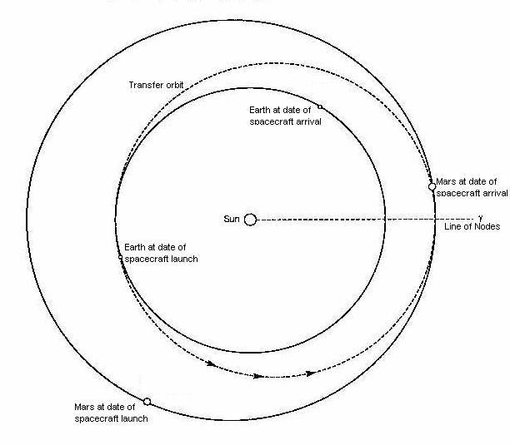

**NASASpaceFlight.com, April 29, 2015**

**Evaluating NASA’s Futuristic EM drive**

[**http://www.nasaspaceflight.com/2015/04/evaluating-nasas-futuristic-em-drive/**](http://www.nasaspaceflight.com/2015/04/evaluating-nasas-futuristic-em-drive/)

**“**Paul March, an engineer at NASA Eagleworks, [recently reported in NASASpaceFlight.com’s forum (on a thread now over 500,000 views)](http://forum.nasaspaceflight.com/index.php?topic=36313.0) that NASA has successfully tested their EM Drive in a hard vacuum – the first time any organization has reported such a successful test.**”**

“The applications of such a propulsion drive are multi-fold, ranging from low Earth orbit (LEO) operations, to transit missions to [the Moon](http://www.nasaspaceflight.com/tag/moon/), [Mars](http://www.nasaspaceflight.com/tag/mars/), and [the outer solar system](http://www.nasaspaceflight.com/2012/01/sls-capability-europa-lander-capability-enceladus-sample-return/), to multi-generation spaceships for interstellar travel.”

“Under these application considerations, the closest-to-home potential use of EM Drive technology would be for LEO space stations – such as [the International Space Station.](http://www.nasaspaceflight.com/tag/iss/)”

“In terms of the Station, propellant-less propulsion could amount to significant savings by drastically reducing fuel resupply missions to the Station and eliminate the need for [visiting-vehicle re-boost maneuvers.](http://www.nasaspaceflight.com/2012/04/atv-3-raises-iss-400km-reboost-power-loss-latest/)”

“If such a similar vehicle were equipped with an EM Drive, it could enable travel from the surface of Earth to the surface of the moon within four hours.

Such a vehicle would be capable of carrying two to six passengers and luggage and would be able to return to Earth in the same four-hour interval using one load of hydrogen and oxygen for fuel cell-derived electrical power, assuming a 500 to 1,000 Newton/kW efficiency EM Drive system.

While the current maximum reported efficiency is close to only 1 Newton/kW (Prof. Yang’s experiments in China), Mr. March noted that such an increase in efficiency is most likely achievable within the next 50 years provided that current EM Drive propulsion conjectures are close to accurate.”

”Specifically, these two proposed missions (to Mars and the outer planets) would use a 2 MegaWatt Nuclear Electric Propulsion spacecraft equipped with an EM Drive with a thrust/powerInput of 0.4 Newton/kW.

With this design, a mission to Mars would result in a 70-day transit from Earth to the red planet, a 90-day stay at Mars, and then another 70-day return transit to Earth.”

” According to Dr. White, “A 90 metric ton, 2 MegaWatt nuclear electric propulsion mission to Mars [would have] considerable reduction in transit times due to having a thrust-to-mass ratio greater than the gravitational acceleration of the Sun (0.6 milli-g’s at 1 Astronomical Unit).”

“Furthermore, this type of mission would have the added benefit of requiring only a “single heavy lift launch vehicle” as compared to “a current conjunction-class Mars mission using chemical propulsion systems, which would require multiple heavy lift launch vehicles.”

Presenting at the “Human Outer Solar System Exploration via Q-Thruster Technology” panel at IEEE, 2014, Mr. Joosten and Dr. White explained that “only 12 days would be utilized spiraling up from a 400 km low Earth orbit to achieve escape velocity and only 5 days spiraling down to a 400 km low Mars orbit.”

” Moreover, this type of EM Drive-enabled mission could negate the need to bring along, for the duration of the mission, a high-speed reentry vehicle to return a Mars crew back to the Earth’s surface because “By quickly spiraling into Earth orbit at the end of the mission, the crew could readily be retrieved via a ‘ground-up’ launch.”

“This means that an EM drive ship mission could be designed without consideration of the every-two-year interplanetary conjunction launch windows that currently govern Earth-Mars transit missions and could help stabilize and provide more routine Mars crew rotation timetables.”

**“**In particular, the Alpha Centauri system, the closest star system to our solar system at just 4.3 lights year’s distance, received specific mention as a potential mission destination.

Mr. Joosten and Dr. White stated that “a one-way, non-decelerating trip to Alpha Centauri under a constant one milli-g acceleration” from an EM drive would result in an arrival speed of 9.4 percent the speed of light and result in a total transit time from Earth to Alpha Centauri of just 92 years.”

**”** However, if the intentions of such a mission were to perform in-situ observations and experiments in the Alpha Centauri system, then deceleration would be needed.

This added component would result in a 130-year transit time from Earth to Alpha Centauri – which is still a significant improvement over the multi-thousand year timetable such a mission would take using current chemical propulsion technology.**”**

“Specifically, a useful EM Drive for space travel would need a nuclear power plant of 1.0 MWe (Megawatts-electric) to 100 MWe.”

“While that sounds significant, the U.S. Navy currently builds 220 MW-thermal reactors for its “Boomer” Ohio class ICBM vehicles.”

“Thus, the technology to build such reactors is available, and the technology needed to build such a device for space-based operations has been around since the 1980s.

The limiting factors for further testing and development of this potentially revolutionary space exploration technology are funding to verify and characterize its operations, and the political will to develop nuclear power for space applications.”

” On April 5, 2015, Paul March reported at NASAspaceflight.com’s Forum that Dr. White and Dr. Jerry Vera at NASA Eagleworks have just created a new computational code that models the EM Drive’s thrust as a three-dimensional magnetohydrodynamic flow of electron-positron virtual particles.”

**Science Alert,** FIONA MACDONALD 1 MAY 2015

NASA has trialled an engine that would take us to Mars in 10 weeks

**And may have inadvertently created a warp drive in the process.**

“NASA scientists [have reported](http://forum.nasaspaceflight.com/index.php?topic=36313.0) that they've successfully tested an engine called the electromagnetic propulsion drive, or the EM Drive, in a vacuum that replicates space. The EM Drive experimental system could take humans to Mars in just 70 days without the need for rocket fuel, and it's no exaggeration to say that this could change everything.

But before we get too excited (who are we kidding, we're already freaking out), it's important to note that these results haven't been replicated or verified by peer review, so there's a chance there's been some kind of error. But so far, despite a thorough attempt to poke holes in the results, the engine seems to hold up.”

**“**The engine is controversial because it seems to violate one of the fundamental concepts of physics - the conservation of momentum, which states that for something to be propelled forward, it needs some kind of propellant to be pushed out in the opposite direction. But the EM Drive doesn't require any propellant in order to create thrust, it simply relies on electromagnetic waves.

However, British scientist Roger Shawyer, who invented the EM Drive in the early 2000s, disagrees that his design violates the conservation of motion. "To put it simply, electricity converts into microwaves within the cavity that push against the inside of the device, causing the thruster to accelerate in the opposite direction," writes Mary-Ann Russon [over at The International Business Times](http://www.ibtimes.co.uk/nasa-says-emdrive-does-work-it-may-have-also-created-star-trek-warp-drive-1499098), who [interviewed](http://www.ibtimes.co.uk/nasa-validates-emdrive-roger-shawyer-says-aerospace-industry-needs-watch-out-1499141)Shawyer after the story on [NASASpaceflight went viral](http://www.nasaspaceflight.com/2015/04/evaluating-nasas-futuristic-em-drive/).**”**

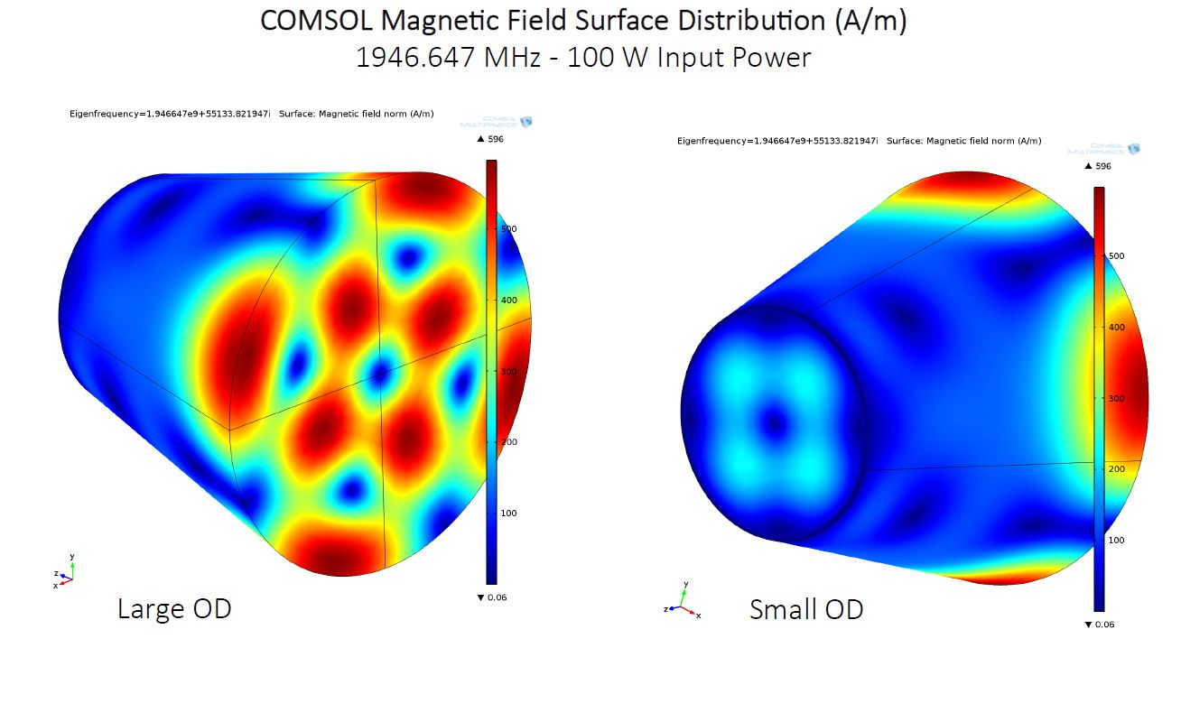

**“**Engineers over at NASA's Eaglework Laboratories have been trying to work out whether or not the results are real for months, and they've now ruled out their main hypothesis for why there would be an error by showing that the engine works in a vacuum. "Despite considerable effort within the NASASpaceflight.com forum to dismiss the reported thrust as an artefact, the EM Drive results have yet to be falsified," write José Rodal, Jeremiah Mullikin and Noel Munson for [NASASpaceflight](http://www.nasaspaceflight.com/2015/04/evaluating-nasas-futuristic-em-drive/), one of the leading space flight news sites.

So what does all this mean? If the results can be replicated and verified in a vacuum (something that Eaglework engineers plan to do in the coming months), it would change the way we travel in space, and open up access not only to planets in our own Solar System, but in the systems beyond.

For starters, our payloads would become a whole lot lighter without the need for rocket fuel. It would also speed things up incredibly.

Harold (Sonny) White, the leader of the research group at Eaglework, predicts that a crewed mission to Mars inside a 2 MegaWatt nuclear electric propulsion spacecraft, powered by an EM Drive with a thrust/power input of 0.4 Newton/kW, could get to Mars in a mind-boggling 70 days.

Even more impressively, the NASA researchers predict that a trip to Alpha Centauri, the closest star system to our Solar System, would take just 92 years.

But Shawyer has some applications closer to home in mind - primarily, he hopes that the engine could be used to send cheap solar-harvesting satellites into space, with the ability to beam the power back to Earth.

"We will go to Mars, but the most important thing is what EM Drive will do for the rest of the world. It will be solar power stations, city-to-city long-haul flights using hydrogen. It's green and convenient and will change our world in the next few decades," [he told Russon](http://www.ibtimes.co.uk/nasa-validates-emdrive-roger-shawyer-says-aerospace-industry-needs-watch-out-1499141).**”**

**“**So where does warp drive come into all of this? The NASA engineers also [reported on the forums](http://forum.nasaspaceflight.com/index.php?topic=37438.0) that they'd fired lasers into the EM Drive's resonance chamber and that some of the laser beams had travelled faster than the speed of light, at around 300,000 kilometres per second... suggesting that the EM Drive may have produced a warp bubble like the kind that allows travel faster than the speed of light in Star Trek.

In reality, a spacecraft travelling at warp speed doesn't actually move faster than the speed of light, but it creates a bubble that warps spacetime around it so it has less distance to travel. NASA has already [created designs](http://www.sciencealert.com/nasas-design-for-warp-drive-spaceship-is-amazing) of what this kind of ship might look like (spoiler: awesome). The presence of this kind of warp bubble is something that the engineers at Eaglework are going to investigate with an [interferometer](http://en.wikipedia.org/wiki/Interferometry).

Of course, all of this requiresa lot of gaps to be filled before we can even verify that results like these are possible. But it seems that we're now in a position where the engine warrants further investigation.

"After consistent reports of thrust measurements from EM Drive experiments in the US, UK, and China - at thrust levels several thousand times in excess of a photon rocket, and now under hard vacuum conditions - the question of where the thrust is coming from deserves serious inquiry," the [NASASpaceflight authors conclude](http://www.nasaspaceflight.com/2015/04/evaluating-nasas-futuristic-em-drive/).

We couldn't agree more.**”**

**The Mind Unleashed, Aug. 1 2015**

[**http://themindunleashed.org/2015/08/the-impossible-em-drive-that-could-reach-mars-in-just-70-days-actually-works.html**](http://themindunleashed.org/2015/08/the-impossible-em-drive-that-could-reach-mars-in-just-70-days-actually-works.html)

# The ‘Impossible’ EM Drive That Could Reach Mars in Just 70 Days Actually Works

**“What if there was an engine that would be fast and powerful enough to make interplanetary and even interstellar travel possible?** There is indeed such kind of engine, which is called EM Drive or electromagnetic propulsion drive, and scientists now confirm that it actually works. According to the estimates, it would take four hours for the EM Drive to get to the Moon and 70 days to get to Mars.

Earlier this year, NASA scientists conducted a series of tests in a vacuum and [announced](http://www.nasaspaceflight.com/2015/04/evaluating-nasas-futuristic-em-drive/) that **the controversial machine really does work.**Now, researcher **Martin Tajmar** of the Dresden University of Technology in Germany also confirmed that the engine produces thrust. But first of all, let’s take a look at how the EM Drive works and why it is so controversial.**”**

#### **“**Why is the EM Drive considered impossible?

The EM Drive technology was invented by British engineer **Roger Shawyer** in the early 2000s. However, the invention was not taken seriously by the scientific community because it, in fact, violates a fundamental law in physics called **the conservation of momentum**. According to this law, to move forward, an object is required to have a propellant pushing it in the opposite direction. The EM Drive works **without a propellant** and uses solar energy instead. Its operation is based on electromagnetic waves, which produce electrical energy that is then converted into thrust. Basically, this means that **the “impossible” engine operates without fuel**.

What is no less controversial about the EM Drive is that **scientists still don’t know how exactly it works.** The most probable explanation is a process called **vacuum polarization**, which is believed to generate short-lived subatomic particles in the quantum vacuum. There is a theoretical possibility that the drive converts these particles into plasma and uses them as a fuel.

#### How powerful is the EM Drive?

The drive could produce thrust **ten times greater than a modern ion thruster** and **several thousand times greater than a photon rocket**. NASA Eagleworks researcher **Dr. Harold White** estimates that a manned mission would get **to Mars in 70 days** and **to Pluto in 18 months** while **a trip to the Moon would only take four hours**. As for interstellar travel, this space propulsion technology could make it possible to **reach Alpha Centauri in just 100 years** while it would take tens of thousands of years with the current technology.

#### The new findings

**Martin Tajmar** is probably the best person to evaluate the EM Drive – his scientific research is focused on“Breakthrough Propulsion Physics.”Unlike the Eagleworks scientists, he decided to investigate the possibility of space propulsion based on the negative matter (which is quite difficult to produce) from a theoretical point of view. As a result, he got a similar amount of thrust to what was originally predicted by Shawyer.**”**

**“**Tajmar presented his [paper](http://arc.aiaa.org/doi/abs/10.2514/6.2015-4083) at the American Institute for Aeronautics and Astronautics’ Propulsion and Energy Forum and Exposition that took place on 27 July.

“Our test campaign cannot confirm or refute the claims of the EM Drive but intends to independently assess possible side-effects in the measurements [sic] methods used so far,” he said. “Nevertheless, we do observe thrust close to the actual predictions after eliminating many possible error sources that should warrant further investigation into the phenomena.”

The next step to the verification of the EM Drive is **a peer-reviewed research**, and Shawyer claims he will have it in a few months. However, even after that, the most probable is that the mainstream scientific community will avoid taking the drive seriously because this will lead to a real revolution in physics – something that, as you understand, is not welcomed by conservative scholars. In any case, let’s hope that one day the EM Drive technology will become a scientific reality and will pave the way for interplanetary and interstellar travel.**”**

**The Telegraph, July 28, 2015**

# 'Impossible' rocket drive works and could get to Moon in four hours

## **The British designed EM Drive actually works and would dramatically speed up space travel, scientists have confirmed**

[**http://www.telegraph.co.uk/news/science/space/11769030/Impossible-rocket-drive-works-and-could-get-to-Moon-in-four-hours.html**](http://www.telegraph.co.uk/news/science/space/11769030/Impossible-rocket-drive-works-and-could-get-to-Moon-in-four-hours.html)

**“**Interplanetary travel could be a step closer after scientists confirmed that an electromagnetic propulsion drive, which is fast enough to get to [**the Moon**](http://www.telegraph.co.uk/news/9499776/Slideshow-Neil-Armstrong-first-man-on-the-moon.html)in four hours, actually works.

The EM Drive was developed by the British inventor Roger Shawyer nearly 15 years ago but was ridiculed at the time as being scientifically impossible.

It produces thrust by using solar power to generate multiple microwaves that move back and forth in an enclosed chamber. This means that until something fails or wears down, theoretically the engine could keep running forever without the need for rocket fuel.

• [**NASA gets set for commercial supersonic flight**](http://www.telegraph.co.uk/luxury/travel/74023/nasa-gets-set-for-commercial-supersonic-flight.html)

The drive, which has been likened to [**Star Trek’s**](http://www.telegraph.co.uk/technology/news/11365243/Scientists-take-first-step-towards-Star-Trek-transporter.html) Impulse Drive, has left scientists scratching their heads because it defies one of the fundamental concepts of physics – the conservation of momentum – which states that if something is propelled forward, something must be pushed in the opposite direction. So the forces inside the chamber should cancel each other out.**”**

**“**• [**Mankind to return to the moon in 2018**](http://www.telegraph.co.uk/luxury/travel/47469/mankind-returns-to-the-moon.html)

However in recent years Nasa has confirmed that they believe it works and this week Martin Tajmar, a professor and chair for Space Systems at[**Dresden University of Technology**](https://tu-dresden.de/en) in Germany also showed that it produces thrust.

The drive is capable of producing thrust several thousand times greater than even a photon rocket and could get to Mars within 70 days or Pluto within 18 months. A trip to Alpha Centauri, which would take tens of thousands of years to reach right now, could be reached in just 100 years.

"Our test campaign cannot confirm or refute the claims of the EM Drive but intends to independently assess possible side-effects in the measurements methods used so far," said Prof Tajmar.

"Nevertheless, we do observe thrust close to the actual predictions after eliminating many possible error sources that should warrant further investigation into the phenomena."

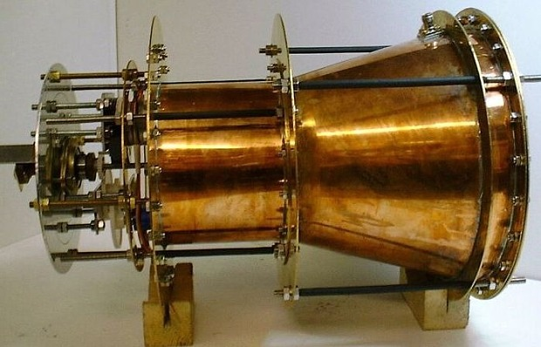

**“**"Our measurements reveal thrusts as expected from previous claims after carefully studying thermal and electromagnetic interferences.

"If true, this could certainly revolutionise space travel."

**“**The EM drive has been likened to the Impulse Drive in Star Trek's vessel of choice, the Starship Enterprise

Shawyer also claims that he is just a few months away from publishing new results confirming that his drive works in a peer reviewed journal.

However scientists still have no idea how it actually works. Nasa suggested that it could have something to do with the technology manipulating subatomic particles which constantly pop in and out of existence in empty space.

Prof Tajmer presented his findings to the 2015 [**American Institute for Aeronautics and Astronautics' Propulsion and Energy Forum and Exposition this week.**](https://www.aiaa-propulsionenergy.org/)**”**